* create script to list all files in /var/log every 5 seconds and append the list to /tmp/list.log file

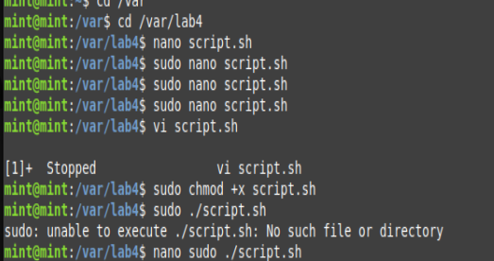

* copy the script to /usr/local/bin directory and set the execution attribute to it



* create systemd service file to execute the the script as background service

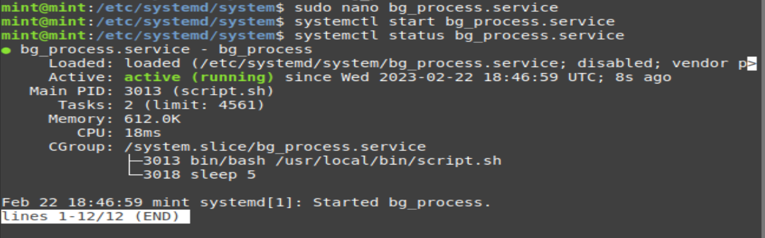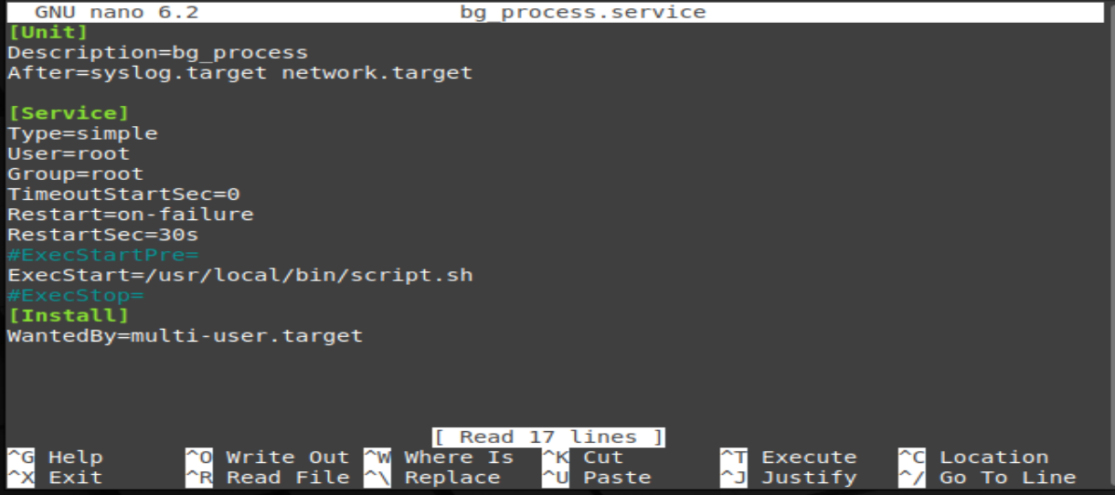

* using cron, schedule a job every 5 minutes to copy /tmp/list.log file to /tmp/list.log.1 and compress the file using zip command

**contab –e**

